## Assignment: 3

Experiment 1: WAP to enter numbers till the user wants. At the end, it should display the count of positive, negative, and Zeroes entered.

**Coding:**

#include<stdio.h>

main()

{

//count=c

   int i, num, c_p=0, c_n=0, c_z=0;

   int arr[100];

   printf("Enter Number: ");

   scanf("%d", &num);

   for (i=0;i<num;++i)

   {

      scanf("%d", &arr[i]);

   }

   for(i=0;i<num;++i)

   {

      if(arr[i]>0)

      {

      ++c_p;

      }

      else if(arr[i]<0)

      {

         ++c_n;

      }

      else if(arr[i]==0)

      {

         ++c_z;

      }

      else

      {

         printf("Wrong Entry\n");

         break;

      }

   }

   printf("+ve Number: %d\n", c_p);

   printf("-ve Number: %d\n", c_n);

   printf(" Zero Number: %d\n", c_z);

}

**Output:**

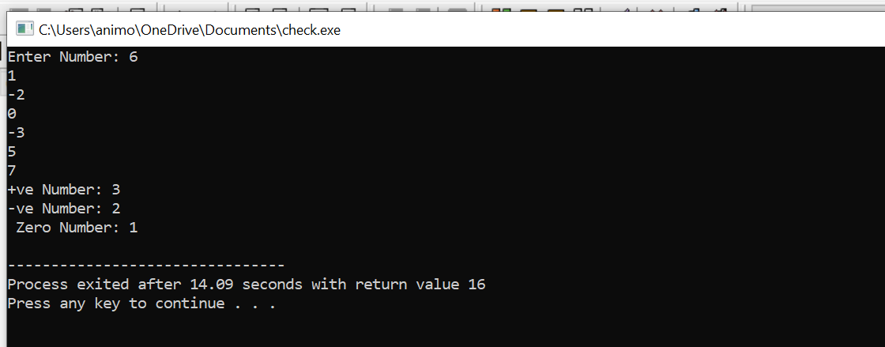

Experiment 2: WAP to print the multiplication table of the number entered by the user. It should be in the correct formatting.

Num * 1 = Num

**Coding:**

#include<stdio.h>

main()

{

    int i,num;

   printf("Enter Any Number: ");

   scanf("%d",&num);

   printf("\nTable For The Given Number: ");

   for(i=1;i<=10;i++)

   {

    printf("\n%d * %d = %d",num,i,num*i);

   }

   return 0;

}

**Output:**

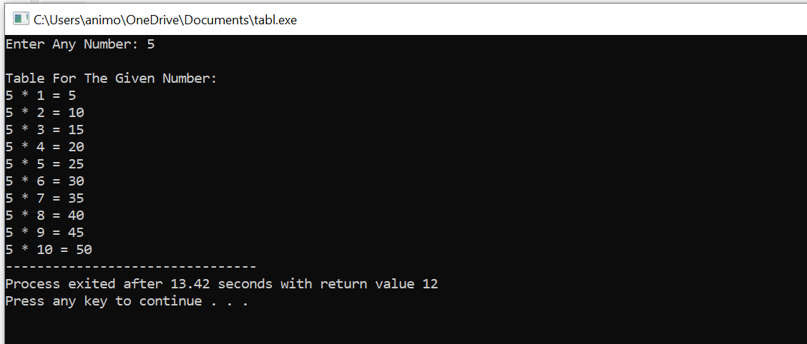

**Experiment 3: WAP to generate the following set of output.**

1. **1**

**2 3**

**4 5 6**

**Coding:**

#include<stdio.h>

int main()

{

   int i,j,k=1;

   for(i=1;i<=3;i++)

   {

      for(j=3;j>=1;j--)

      {

         if(j>i)

         printf("");

         else

         printf("%d", k++);

      }

      printf("\n");

   }

   return 0;

}

**Output:**

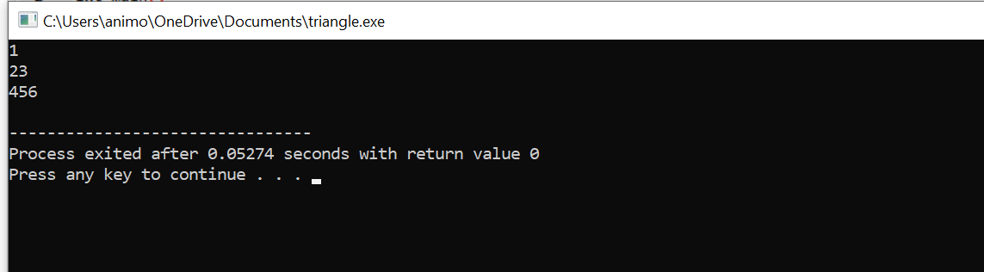

1. **1**

**1 1**

**1 2 1**

**1 3 3 1**

**1 4 6 4 1**

**Coding:**

#include<stdio.h>

int main()

{

   //row=r, coloumn=c

   int val=1,r,c;

   {

      for(r=0;r<5;r++)

      {

      for(c=0;c<=r;c++)

      {

         if(r==0 || c==0)

         val=1;

         else

         val=val*(r-c+1)/c;

         printf("%5d", val);

      }

      printf("\n");

   }

}

    return 0;

}

**Output:**

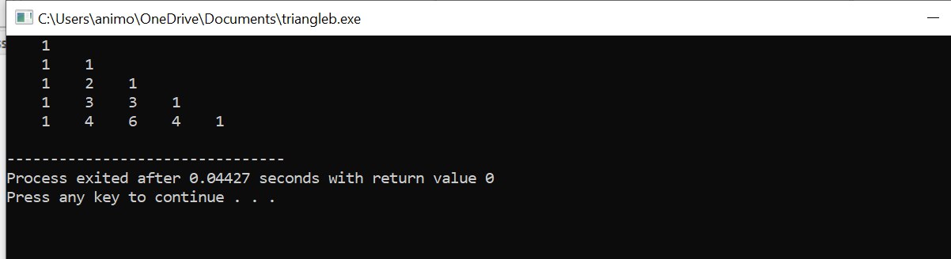

**Experiment 4: The population of a town is 100000. The population has increased steadily at the rate of 10% per year for the last 10 years. Write a program to determine the population at the end of each year in the last decade.**

**Coding:**

#include<stdio.h>

int main()

{

   int i , population=100000;

   for(i=1;i<=10;i++)

   {

      population = population - population*0.1;

      printf("%d year: %d\n", i,population);

   }

   return 0;

}

**Output**

